**Assignment -1**

Digital Marketing

|  |  |
| --- | --- |
| Student Name | Angeline Daphne K |
| Student Roll Number | 20URCS005 |
| NM ID | C359CF15BB6916A915C4DABC209622CE |
| College Name | AAA College of Engineering and Technology |

**QUESTION:**

**Create a blog or website using Blogspot and WordPress. Customize the theme design and post new article with 500 words.**

**BLOG USING BLOGSPOT:**

**Blog link:** https://donutsdazzle.blogspot.com/2023/08/delightful-donuts-sweet-journey-into.html

**Blog Title: Delightful donuts**

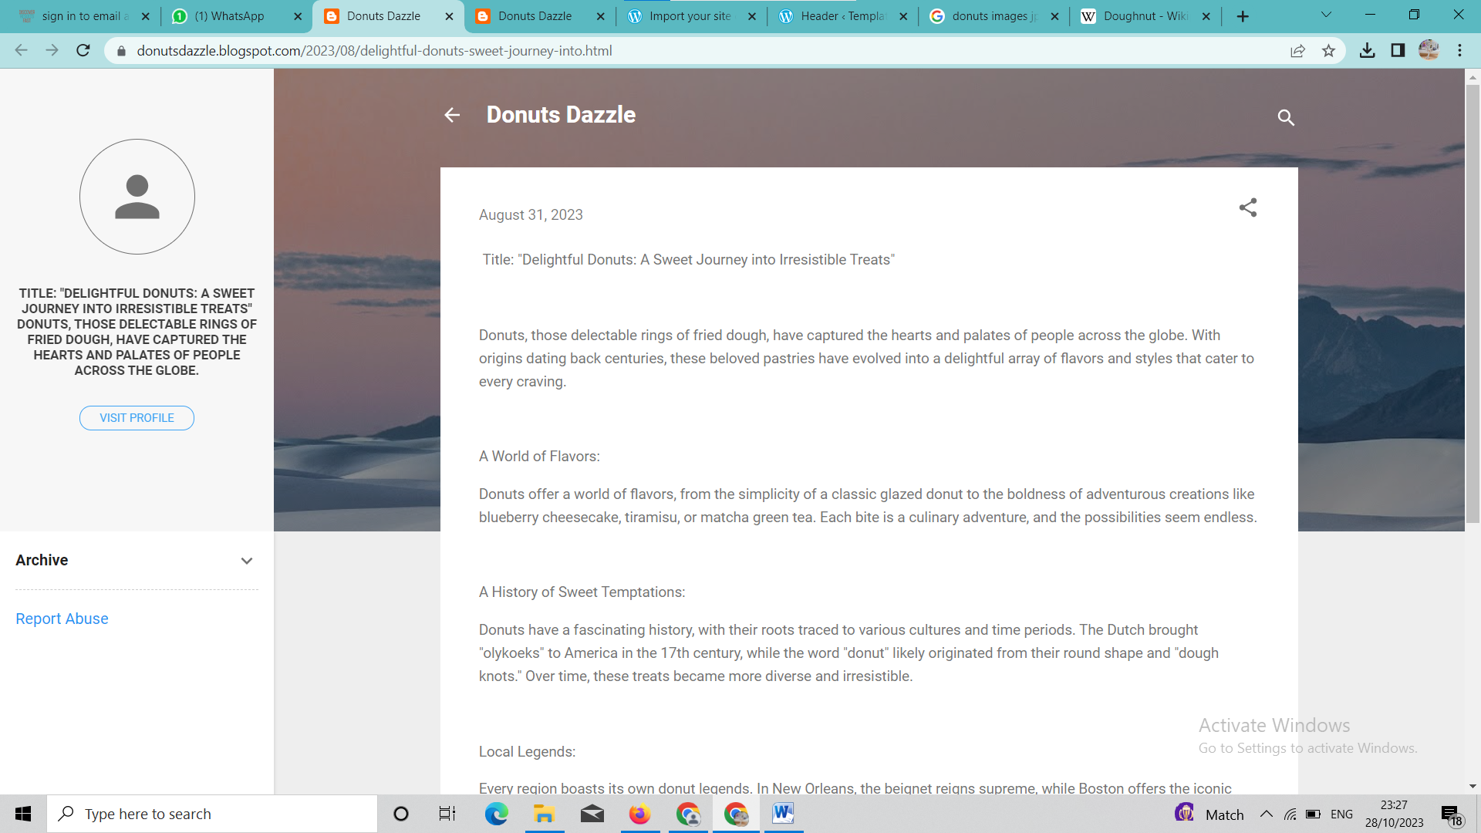

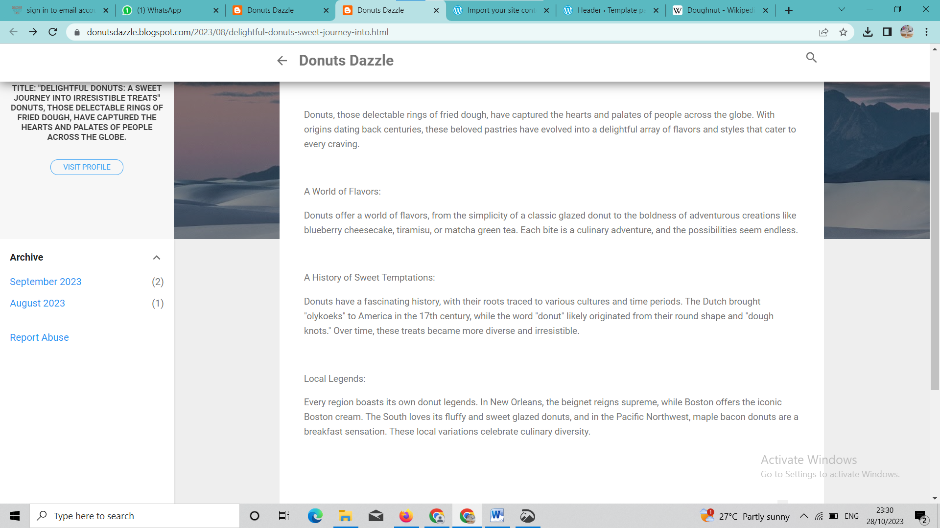

**BLOG USING WORDPRESS:**

**Wordpress link: https://donutsdazzle.wordpress.com/wp-admin/site-editor.php?postId=pub%2Fcreatio-2%2F%2Fheader&postType=wp_template_part&canvas=edit**

**Blog Title: delightful donuts**

